Aryan Sai Venkat

230701040

CSE A

# EXP NO:7 IPC USING SHARED MEMORY

## PROGRAM

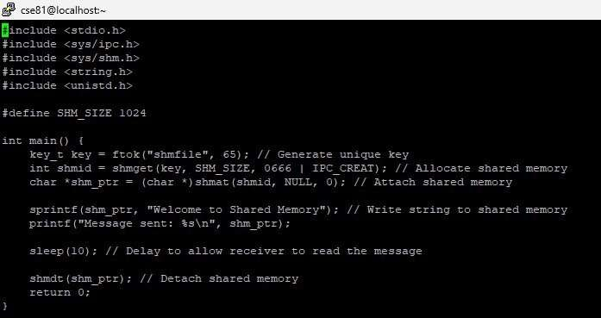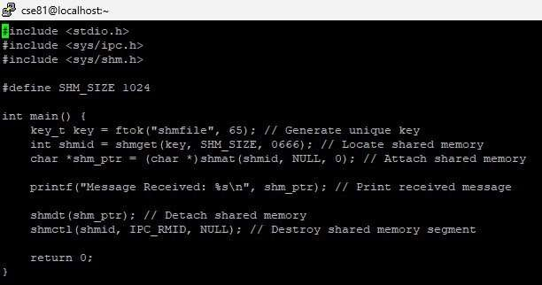

## OUTPUT

## 